Reserve your spot today!
Friday September 30th – Sunday October 2nd, 2016
Camp Byng, Roberts Creek (Sunshine Coast)
History
Camp Byng is a unique, 200–acre campground situated on the Sechelt Peninsula, also known as the Sunshine Coast.

Camp Byng consists of 4 lodges with hulls, treed camping areas, creeks, 2 meadows with shelters, a chapel and many trails for the ultimate outdoor experience.

A kilometer long ocean waterfront affords opportunities for beach activities, studying marine life and watching passing cruise ships.

Since its official opening in 1922, Camp Byng has hosted thousands of Scout youth and other youth organizations.

It Starts With Scouts!
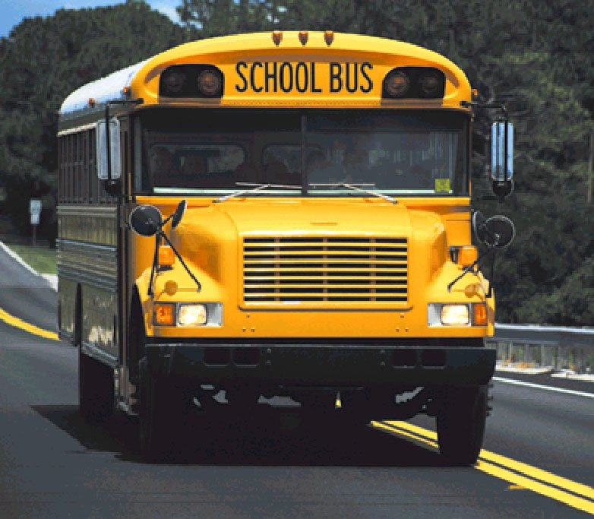
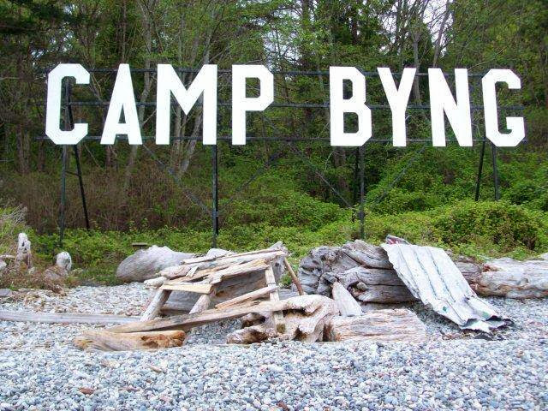
Camp Fee
- $50.00 per registered youth
- $50.00 per sibling/parent helper
- $50.00 per registered leader

Note: These fees do not include the cost of the ferry.
The camp fee DOES include your bus trip to and from Camp Byng. Reserve your seat ASAP!

Travel
Your camp begins with a 40 minute ferry ride from Horseshoe Bay (a half hour drive from Vancouver) through the picturesque islands of Howe Sound to the Sunshine Coast to Langdale Terminal. It is a 10 minute bus drive from the ferry terminal at Langdale to Camp Byng.

Leaders & Youth travelling to and from Camp Byng should be in full uniform. Casual clothes while in Camp. Group scarf must be worn at all times.

Departure: September 18, 2015 Horseshoe Bay Ferry Terminal on the 5:50pm Ferry and returning on Sunday on the 2:45pm Ferry. Please arrive at Camp Byng by 8:30-9:00 pm at the latest if travelling on your own.

Contact Leaders please check in at Haida Lodge registration desk.

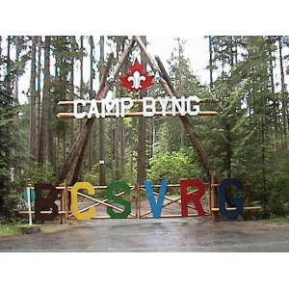
CUBOREE 2016

FAQ’s & Pre-Registration Information
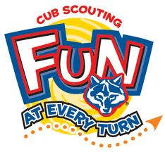

- What does the Cuboree Registration Fee include?
- Transportation from Langdale Ferry to Camp Byng and back.
- All meals while at Cuboree.
- All activities while at Cuboree.
- 201 Cuboree Camp Crest.

- What is not included in the Cuboree Registration Fee?
- The price of the ferry to Langdale (see BC Ferries Rates www.bcferries.com – Horseshoe Bay to Langdale).
- Any cars on the ferry. This is a Pack decision as we have buses arranged for the Cubs once off the ferry in Langdale.
- Dinner on the ferry; bring some money or your dinner.

- How will the process work for those that are walking on the ferry? Will there be a truck to transport our luggage to and from Camp Byng?
- Yes! The service team has arranged for the Luggage Truck to be available for loading gear at Highlands United Church, 3255 Edgemont Blvd. North Van (** Come to the back of the church taking Brookridge Dr and turn in roundabout.) for walk-on passengers.
- Loading of the Luggage Truck will be Thursday September 29th , 2016 at 6:00 – 8:00 pm.
- NOTE: The buses to camp DO NOT carry gear!
- The Luggage Truck will arrive at Camp Byng and the Cubs will collect their gear from the truck and proceed to their Hulls.
- On the return trip from Camp Byng, the Luggage Truck will be available in Horseshoe Bay at the waterfront park which is to the right of Sewell’s Marina and just below the Horseshoe Bay Ferry Terminal. Cubs and their luggage will be picked up there.

- How do I book a seat on the bus to and from camp?
- This will be done by your Pack Leaders who will send us the list and numbers of your Pack and how many seats you will need on the bus.

- Can we pre-book sleeping arrangements?
- Yes! Please register and advise the number of youth and leaders attending camp. We’ll assign your hulls/campsites in advance.

- Where do Cubs sleep? What equipment is each Pack required to bring?
- 1st & 2nd year Cubs will be sleeping in hulls and need to bring the following:
  - Sleeping bags, no foam pads required. NOTE: Please ensure that your Cub has a proper sleeping bag as it gets cool at night – all sleeping bags should have a temperature rating (approximately -10 degrees)
  - Pillow and campfire blanket (use that instead of carrying an extra blanket).
  - Pack all in a backpack – NOT a garbage bag. If you must use a garbage bag, please use transparent garbage bags to distinguish your bag from the black, green and orange garbage bags commonly used at camp.
  - Backpacks preferred to pack all Cub gear. NO suitcases or wheeled luggage please.

- 3rd year Cubs will be sleeping in tents with the Scouts and need to bring the following:
  - Sleeping bags, foam pad and mess kit (knife, fork, spoon, cup and plate) required. NOTE: Please ensure that your Cub has a proper sleeping bag as it gets cool at night – all sleeping bags should have a temperature rating (approximately -10 degrees)
  - Pillow and campfire blanket (use that instead of carrying an extra blanket).
  - Pack all in a backpack – NOT a garbage bag. If you must use a garbage bag, please use transparent garbage bags to distinguish your bag from the black, green and orange garbage bags commonly used at camp.
  - Backpacks preferred to pack all Cub gear. NO suitcases or wheeled luggage please.

- Can Cubs/Leaders/Parents tent if preferred?
- Yes. Cubs, Leaders and parents have the option to tent (you bring your own and all necessary gear with it).
- Please advise your numbers preferring to tent and we’ll assign your tent area in advance.

- Do we need to bring a mess kit (dishes & cutlery)?
- No for 1st & 2nd year Cubs – we will provide dishes and cutlery.
- Yes for 3rd year Cubs tenting with the Scouts – you will be cooking your own meals.

- What equipment is each person required to bring?
- See the attached Equipment List.

- WHAT NOT TO BRING TO CAMP
- Electronic equipment and video games.
- Extra food snacks (candy, chocolate, etc.).
- Check with your Leader for what not to bring to camp.

- How can Scouts or Venturers attending Cuboree help?
- Scouts can attend as either an offer of service or can participate in the camp.
- Venturers are welcome to assist at any Round Robin station.
- We ask for help for campfire, prepping and maintaining the campfire (under the guidance of the Campfire Chief).
- Venturers help is particularly required at the Archery Range.

- What is the program at Cuboree 2016?
- Groups rotate through eight (8) stations in 45 minute sessions in a Round Robin format from 9:00 am – 5:15 pm.
- There will be a 5 minute warning whistle to wrap up and head to the next station.
- Snack tables will be set up at a flag area to individually distribute morning and afternoon snacks.
- Carry your daypacks until needed. The Camp Schedule includes all Round Robin station information and locations. Programming to be updated shortly.

Cuboree needs all Leaders and parent volunteers to participate in supporting the camp. Each Pack leadership team is required to help in all areas as listed:

Support is required in the following areas:

Program
All gear supplied by Pack supervising Round Robin Stations excluding Archery, Knife Work, Fire Building.
We are open to suggestions on the balance of the stations (pick a station between 1-8 please).
Participate in the duty roster scheduled. Discussed at the Leader’s meeting – held when the Cubs are in bed.

At Camp Chief Discretion: Submit expenses for authorization before purchasing anything.

Camp Chief – Bill Edge Camp Cook – Katherine Elliot Camp First Aider - TBD

Kitchen Duty Under Camp Cook’s instruction.
- Prep and Service of meals
- Set up and clear away of meals
- Dish duties (washing and putting away once dried)
- Leaders/parents on Kitchen Duty turn up at the kitchen 1 hour prior to meal time.

Mess Hall Under Camp Cook’s instruction.
- Prep of Dining Hall – set up of tables, chairs, meal service counters, sanitizers and related duties.
- Floors swept after each meal, mopped after dinner.
- Garbage bags & recycling boxes emptied and taken to the large containers - Skeena parking lot.
- Clean up of the Mess Hall, fireplace room and balcony eating areas.
- Standby to help the Kitchen Duty crew at Camp Cook’s request.

Hull Supervisors
- Supervises Hull cleanliness and maintenance throughout camp and clean up at the end of camp.
- Responsible for Hull safety during camp.
- Clean up: all bags removed, garbage removed, swept, doors closed and ready for Ranger inspection.
- Once Ranger inspected and approved - Hulls are off limits to all.

Cabin Supervisors
- Supervises Cabin cleanliness and maintenance throughout camp and clean up at the end of camp.
- Responsible for Cabin safety during camp.
- Clean up: all bags removed, garbage removed, swept, doors closed and ready for Ranger inspection.
- Once Ranger inspected and approved - Cabins are off limits to all.

KYBO’s
- Clean up and restock throughout camp. Camp Ranger arranges re-stocking supplies with Camp Chief.
- Assign KYBO supervisors who schedule each group for cleanup/restocking duty.
- KYBO supervisors lock all washrooms except 1 (Skeena Girls washroom) for all to use.
- Final clean up by KYBO supervisors.

END OF CAMP October 2nd, 2016 Camp Clean up.
Sunday – after breakfast – youth walk the campsite picking up garbage – encouraging Leave No Trace.

What else should Pack Leaders need to prepare and bring to Cuboree?

- Contact Leaders are to carry their Pack’s first aid kit to camp.
- First Aid Kits must be carried to each station with the Cubs.
- The Leader travelling around with the Cubs to each Round Robin station should be a First Aider with certification.
- Please bring a copy of your First Aid certificate to Camp. This copy can be sent in with the registration package or handed in to the camp registrar.
- Prepare two (2) campfire skits, songs and cheers for campfire.

Safety – Leader Night Shift Patrol
To be discussed and assigned at camp.

Medication, Allergies and all things related

- Any medication or allergy equipment (Epi-pens, Benadryl, asthma puffers, etc.) We insist that the Leader is made aware that the youth in his/her charge is so equipped, and what reason the youth is so equipped, and what conditions they are taken for. This information should appear on the medical form when it is filled out.
- Epi-pens should be on the youth or adult at all times.
- Acetaminophen (Tylenol) and ibuprofen (Advil) along with other over the counter or patent medicines can be held by the Pack Leaders.
- The Camp First Aider is NOT equipped with a range of over the counter medications.
- Leaders and parents should know that these will only be administered after a thorough review of the youth’s condition, and their medical form, or the youth/adult will be sent to the hospital.
- All Leaders must inform registration and the First Aid attendants on site.
- A form is required listing all youth/leaders with allergies and a photograph clearly identifying the individual posted by the information listed.
  - Two (2) copies required – one for registration & first aider and one for kitchen staff.
- ASA (aspirin) is to be discouraged due to the remote possibility it could cause Reye’s Syndrome in teenagers.
- The onsite First Aiders have basic training or better. However:
  - Each Pack must have a first aid attendant at camp.
  - Each Pack must carry their own first aid kit.
  - Detailed information on all youth with medical issues is held by the Camp Chief and Camp First Aider.

Leaders take particular note

- Smoking is permitted by adults only in DESIGNATED areas. The balance of camp is non-smoking. All buildings are non-smoking.
- Use or possession of any alcohol or recreational drug/substance is not permitted.
- Firearms, fireworks, paint ball guns, sling shots, and similar devices are not allowed in camp.
- All people attending the camp must sleep in a lodge, hull or tent. Sleeping in vans, campers, trailers, RV’s etc. is not permitted.
- Scout groups must have appropriate documentation for each person attending camp as set out in Scouts Canada Bylaws:
  - Leaders are responsible for the health, safety and conduct of their camps and all their camp participants.
  - Contact Leader to hand in health forms to the registrar and advise of any allergies (food or medication) at check in. Food allergies to be noted and provided to Camp Chief two (2) weeks in advance of camp.
  - Health forms must clearly indicate the youth or adult and the allergy alert. Health forms will be returned at the closing ceremonies along with Camp Crests.
- Pets are not permitted at Camp Byng.
- All garbage is to be placed in the garbage dumpster located in the Skeena parking lot. Cardboard and boxes (ie: cereal boxes) are to be flattened and placed in the cardboard dumpster located in the Skeena parking lot.
- Swimming is not recommended at the Camp Byng beaches due to tides and currents. Group leaders are responsible for providing their own safety checks and adequate water activity supervision for youth within three (3) metres of the water (on or in the water).
- Fires are permitted only at designated campfire sites. No fires on the waterfront foreshore. Do not cut down trees for firewood.
- Raiding of other tents, hulls, lodges or campsites is prohibited.

CAMP RULES

- Leaders are responsible for their youth at all times! Leaders are responsible for the health, safety and conduct of their camps and all their camp participants.
- Cuboree is your camp. Keep it clean, neat and in great shape.
- NO FOOD in hulls, tents or lodges.
- No toiletries in hulls or tents. Keep toiletries in a ziplock baggie in the washrooms or assigned area.
- Buddy System – Don’t go anywhere without a Buddy!
- Knives are to be put away unless being used at a Round Robin station.
- Bear Talk: Leaders please discuss before coming to camp. It will be reinforced at the Opening Ceremony.
- Out-of-Bounds Areas: Streambeds, roadways, workshop buildings and area, residences, private property located outside the camp boundary, spiritual centre, behind the archery range and other areas as marked.
- Kitchen is out of bounds for youth. Leaders or parents permitted for kitchen duty.
- Candles and other flames, open or contained, are not permitted in hulls or tents – use battery powered devices only. Camp lanterns, stoves and heaters are not to be used in hulls or tents.
- Any vandalism, damage to buildings or equipment, etc. will be charged to the Group.
- Groups are responsible for your own first aid personnel and equipment. The First Aider and first aid supplies are to be supplied by the Group. Any significant injury or incident that occurs on Camp Byng property must be reported to the Camp Chief who will report to the Camp Ranger as soon as possible.
- All noise must cease by 11:00 pm out of respect for our neighbours.
- Please leave a campsite cleaner and better than you found it. Groups are responsible for all cleanup of lodges, campsites, shelters, washrooms, or other areas used by the Group while at camp.

Thank you for leaving the camp better than you found it.

Equipment and Packing List

- Sleeping bag – Again please ensure the Cub has a real sleeping bag for warmth – all sleeping bags should have a temperature rating (approximately -10 degrees).
- Camp pillow
- Large transparent garbage bag for wet clothing – green, black or orange garbage bags can be mistaken for actual garbage.

Back Pack (No suitcases) lined with transparent garbage bag – which ensures your gear has one more chance to stay dry should your bag get wet. Your backpack should contain:

- Uniform – worn to and from camp
- Extra bags for wet clothes (plastic shopping bags). Put all plastic bags in a transparent garbage bag.
- Waterproof jacket, pants
- Hat (with brim)
- Hiking boots
- Two (2) complete changes of clothes (shirt, pants, socks, underwear, etc)
- Four (4) pairs of socks.
- Sleepwear
  - 1 sweat pants or PJ pants
  - 1 sweat shirt preferably with a hood or PJ shirt
  - 1 toque (polar fleece recommended)
  - 1 pair lightweight gloves (polar fleece recommended)
- Toiletry kit
  - Small towel
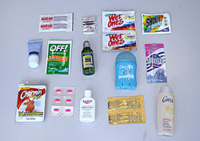
  - Soap
  - Toothbrush
  - Toothpaste
  - Comb/brush
  - Washcloth
- Daypack – carry your stuff around camp
  - Water bottle
  - Sunglasses
  - Sunscreen lotion
  - Bug spray or lotion
  - Flashlight/headlamp (including fresh batteries and spares)
  - Compass
  - Whistle
  - Camera (including fresh batteries)
  - Your own personal first aid kit (optional)
    - In a ziplock bag: 4 small bandaids, 1 safety pin, 1 sample pack of polysporin, 2 pack handi wipes

If tenting:
- Tent and necessary equipment
- Foamy
- Ground sheet or tarp

3rd Year Cubs camping with the Scouts do not need to bring tents – they are provided.

