Equipment and Packing List

- Sleeping bag – Again please ensure the Cub has a real sleeping bag for warmth – all sleeping bags should have a temperature rating (approximately -10 degrees).
- Camp pillow
- Large transparent garbage bag for wet clothing – green, black or orange garbage bags can be mistaken for actual garbage.

Back Pack (No suitcases) lined with transparent garbage bag – which ensures your gear has one more chance to stay dry should your bag get wet. Your backpack should contain:

- Uniform – worn to and from camp
- Extra bags for wet clothes (plastic shopping bags). Put all plastic bags in a transparent garbage bag.
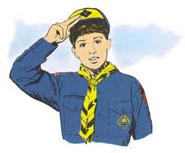
- Waterproof jacket, pants
- Hat (with brim)
- Hiking boots
- Two (2) complete changes of clothes (shirt, pants, socks, underwear, etc)
- Four (4) pairs of socks.
- Sleepwear
  - 1 sweat pants or PJ pants
  - 1 sweat shirt preferably with a hood or PJ shirt
  - 1 toque (polar fleece recommended)
  - 1 pair lightweight gloves (polar fleece recommended)
- Toiletry kit
  - Small towel
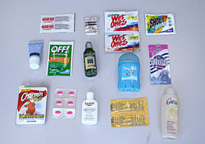
  - Soap
  - Toothbrush
  - Toothpaste
  - Comb/brush
  - Washcloth
- Daypack – carry your stuff around camp
  - Water bottle
  - Sunglasses
  - Sunscreen lotion
  - Bug spray or lotion
  - Flashlight/headlamp (including fresh batteries and spares)
  - Compass
  - Whistle
  - Camera (including fresh batteries)
  - Your own personal first aid kit (optional)
    - In a ziplock bag: 4 small bandaids, 1 safety pin, 1 sample pack of polysporin, 2 pack handi wipes

If tenting:
- Tent and necessary equipment
- Foamy
- Ground sheet or tarp

3rd Year Cubs camping with the Scouts do not need to bring tents – they are provided.

